#John David Conley

#Machine Learning

#Assignment 5

#11-8-2022

#https://github.com/DavidConley/machinelearning05

<https://youtu.be/2o4QCVb7y7I>

1:

a:

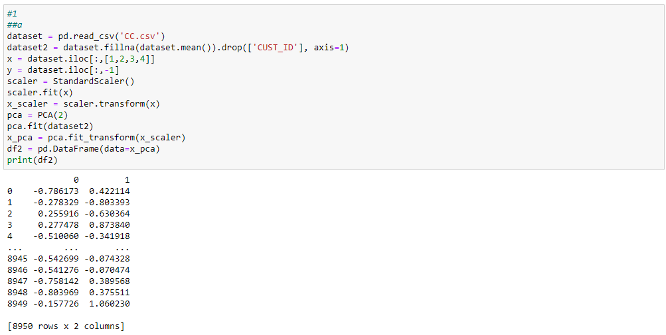

Using PCA on CC dataset

b:

Using K-means on result

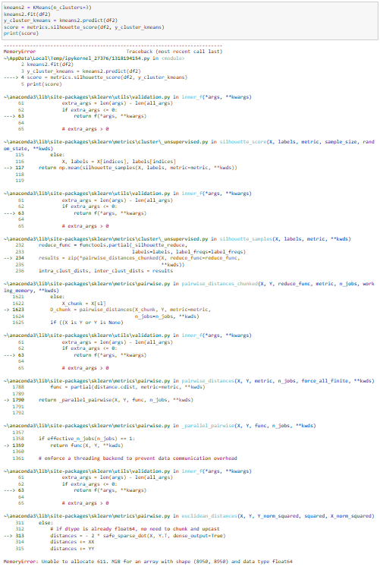

Unfortunately, this always led to a memory error on my machine no matter how much I adjusted it. Maybe it can run on a different machine.

c:

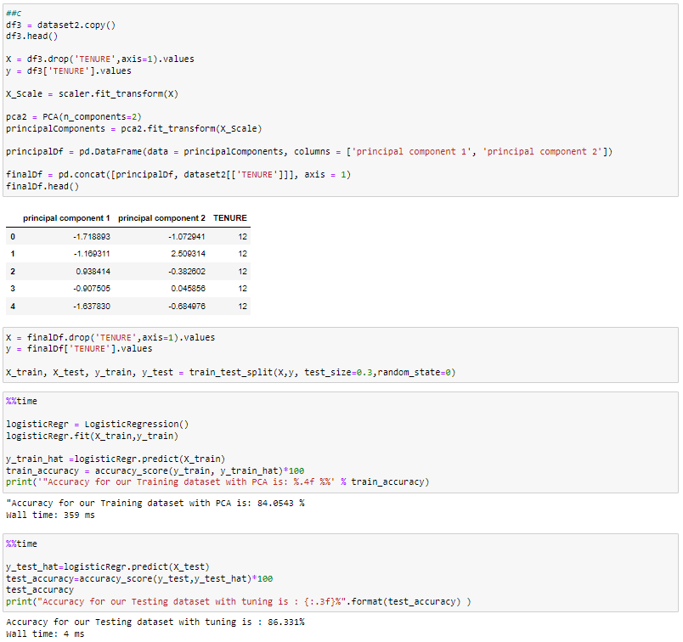

Scaling, PCA, and K-means followed by performance testing

2:

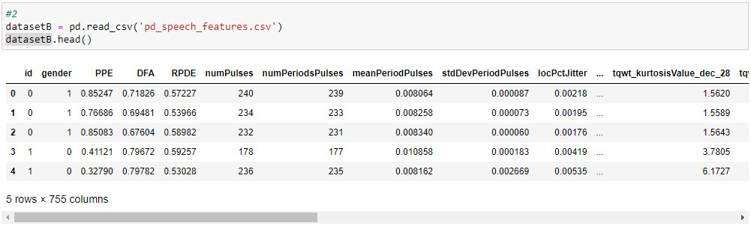

reading

a:

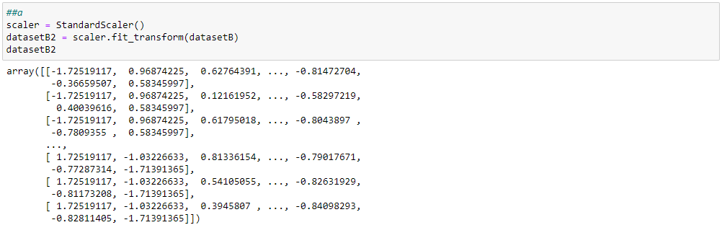

scaling

b:

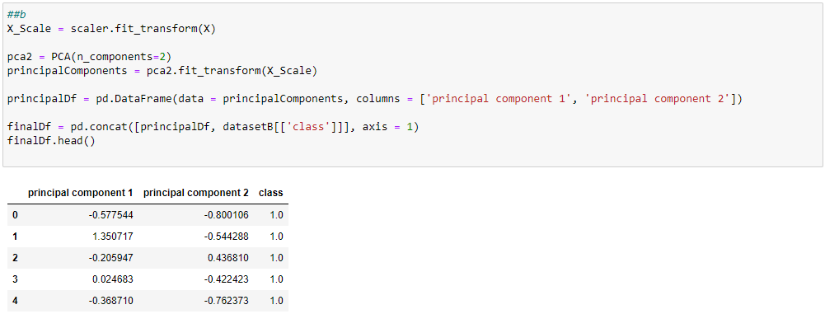

PCA’ing

c:

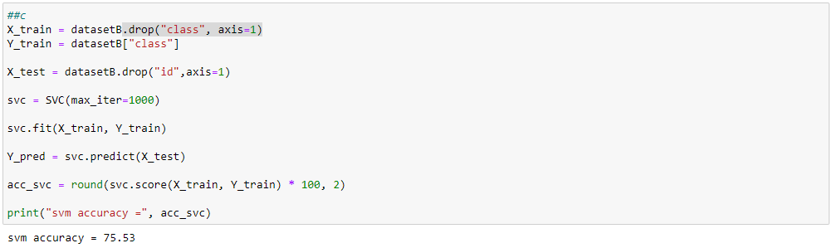

performance reporting through SVM

3:

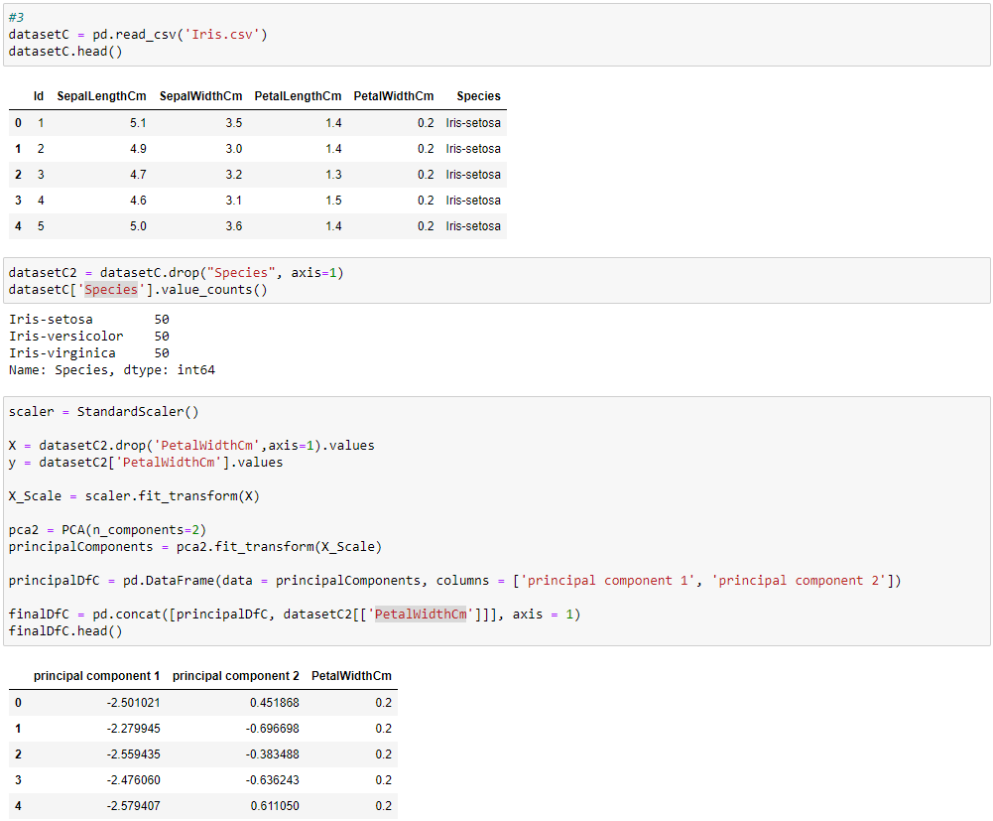 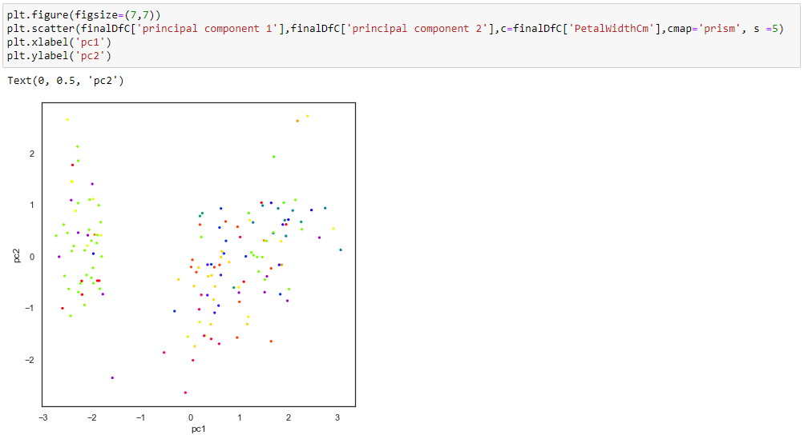

LDA to make a 2D scatter plot